ADa – star schema Your Name:

For the model below:
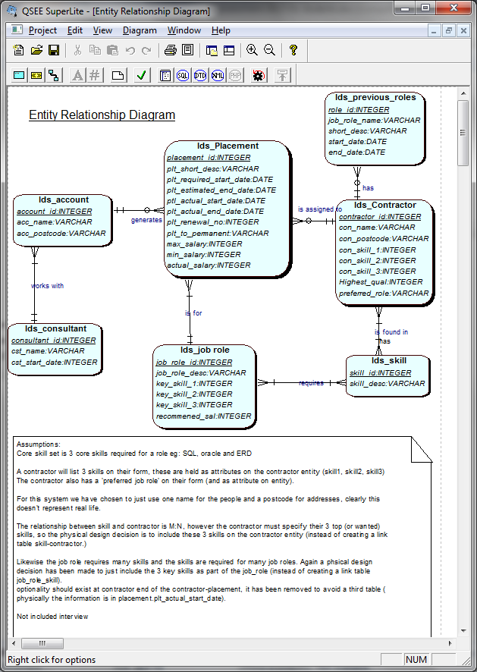

1.………………………………………………………………………………………………………………

List 3 queries that an investor in PlaceU may want to know:

No of placements turned into full time employment per year
How many new contractors per month
How many new placements per year
Avg actual salary all placements per year
No of placements secured by consultant per year
Amount of revenue (total salary) per account per year
No_of_applicants per job role per year
No_of placements secured per year
No_new_accounts per consultant per year

No-contractors per skill set per year
No-contractors without placements per year
No_consultants per account per year/month/quarter

No-contractors per salary_band per job_role per year

Star Methodology (consider using this for your assignment…)

List & clarify relevant business question(s) that need to be answered for the Investor

Eg, investigate skills sets required
Investigate skill sets of potential contractors

What Dimension tables are required (name them eg time_dim)

Time_dim
Skill_set_dim

Identify lowest level of granularity (for each Dimension)

Quarter/month/year

Identify the measures to support the business questions (calculations or facts)

COUNT / SUM/ AVG

MAX/MIN

Algorithm – SUM/COUNT %

Define (name, data type) suitable attributes of the Dimension tables

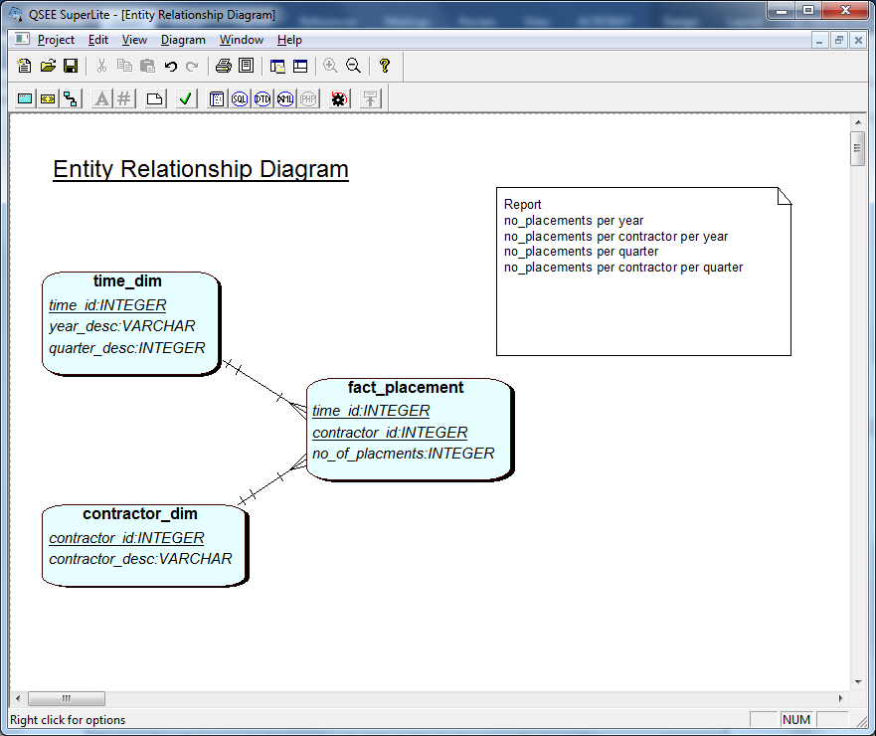

Define (name, data type) the Fact table (keys and measures)

As above

Draw the Star Schema (using QSEE) and create a table (in word) to illustrate the data for each table in the star schema.

As above

Create a data dictionary to document each of the tables in the star schema model.
Show where each piece of data in the star schema comes from (from the PlaceU_lds and SkillUP systems), describe mappings and transformations.
Research data dictionaries and add to the data dictionary metadata that would be valuable.

Look into crisp methodology

Data in tables to support reports above in star schema

Time_dim
1 | 2013 | 1
2 | 2013 | 2
3 | 2013 | 3
4 | 2013 | 4
5 | 2014 | 1
6 | 2014 | 2
7 | 2014 | 3
8 | 2014 | 4
9 | 2015 | 1
10 | 2015 | 2
11 | 2015 | 3
12 | 2015 | 4
100 | 2014 | Null  To deal with report of all placements per year

Contractor_dim (cont_id, original_id, con_desc)
1 | 10 | Liam Love
2 | 11 | Mandy More
3 | 12 | Neil Noel
4 |  | ….
Added surrogate key in case we have contractors with the same id in both lds and SkillUp | … also add contractors from SkillUP  Problem with ids …

Fact_placement
Report_id, Time_id, contractor_id, no_of_placements
1 | 1 | 10 | !!! work it out - 2
2 | 2 | 10 | 0
3 | 3 | 10 | 0
4 | ….
Added surrogate key so we can have reports for ‘all contrctors’ | 1 | 11
 | 2 | 11
 | 3 | 11
100 | 100 | 10 | 4
101 | 100 | null | 250

Data dictionary – on per table
Research …

Time_dim
column | datatype | constraints | Data source | Check?
Time_id | Integer(2) | Not null, key | sequence
Year_desc | Varchar2(4) |  | Automatic – with update/ maintenance  OR  From placement_start_date on lds_placement | ‘first’ not ‘1’

Predicted table size
Access paths
How data is maintained?
Data uploaded?
SCD ---

Look online and see what else to include in your DD, Data warehousing dimensions and facts.

